PROJECT ARCHITECTURE
FEATURES

Field | Details
Date | 26 June 2026
Team Id
Project Name | House Rent
Maximum Marks | 4 Marks

Features
The HOUSE RENT application provides users with a convenient platform to search, explore, and manage rental properties. The application includes features that improve the property search experience while helping users make informed rental decisions.

1. Advanced Property Search
The application provides an advanced search system that allows users to quickly find properties matching their preferences.
Key Features
- Filter properties by location.
- Filter by price range.
- Search based on property type (Apartment, Villa, Independent House, etc.).
- Filter by property size.
- Search according to the number of bedrooms.
- Filter using amenities such as:
  - Pet Friendly
  - Swimming Pool
  - Garage
  - Parking
  - Furnished Properties
Saved Searches
Users can save their preferred search filters and easily access matching property listings in future searches.

2. Market Insights and Trends
The application provides useful information to help users make better rental decisions.
Price Trends
Displays rental price trends in different locations, allowing users to compare prices before selecting a property.
Neighbourhood Insights
Provides information about nearby facilities including:
- Schools
- Hospitals
- Public Transport
- Shopping Areas
- Safety and Crime Information
This helps users understand the surrounding area before renting a property.
Investment Potential
Displays information about property value appreciation and investment opportunities, helping users identify properties with long-term value.

Advantages of These Features
- Makes property searching faster and easier.
- Helps users compare multiple properties efficiently.
- Provides valuable neighbourhood information.
- Supports informed rental and investment decisions.
- Improves the overall user experience.

Example – Features Diagram:
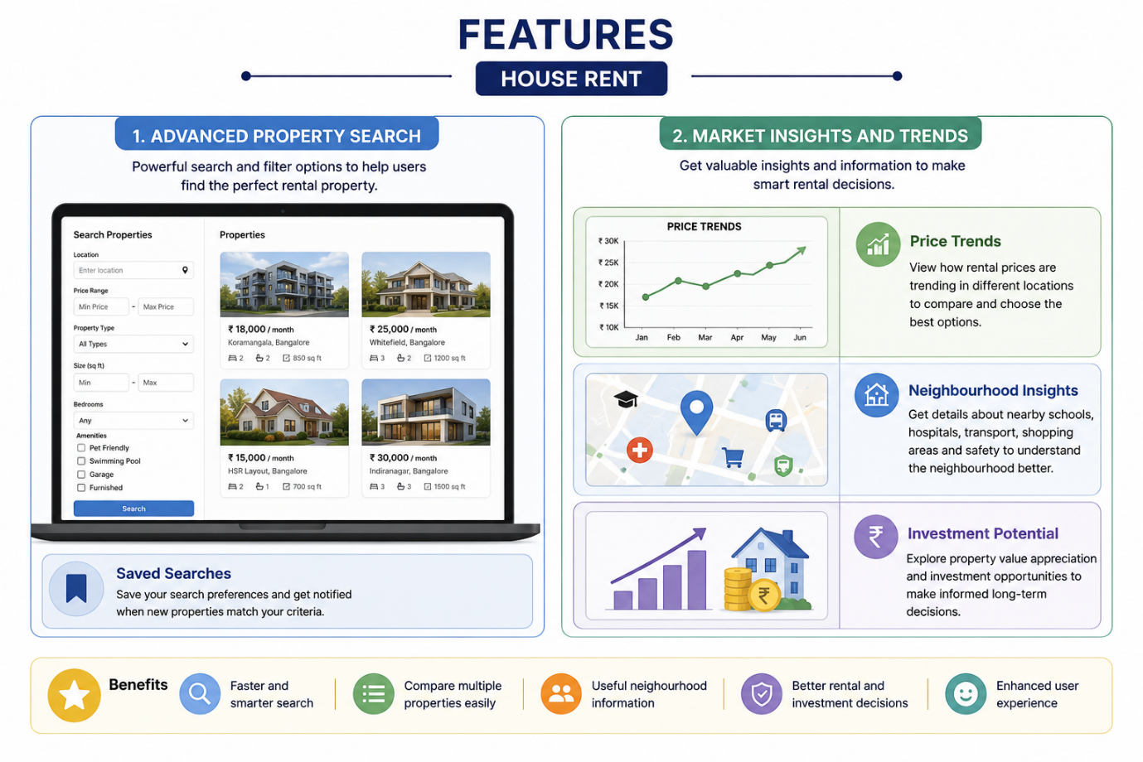

Figure 1: Features Architecture of the HOUSE RENT Application.

Reference:
- https://www.zillow.com/
- https://www.magicbricks.com/
- https://www.99acres.com/

